Nad Sadhna
Institute for Indian music and research centre
Annual report 2018-2019
The past year has been an active one for our organization and I hope that you will review the statistics and photos we have offered in this annual report. In addition to the activities, our board was busy in 2018-19 with efforts to strengthen our organization that included “review and update of mission and by-laws” and “Development of an organizational plan”. As you can see, we believe in operating our organization as effectively and efficiently as possible.
About Nad Sadhna
Nad Sadhna Institute for Indian Music and Research Centre (www.nadsadhna.com) has tried to unfold the beauty & treasure of Music before its worshippers. “Nad Sadhna” is an organization fully dedicated to Music, arts and culture based in Jaipur; the city better described as the cultural capital of India.
Nad-Sadhna is a place where researchers in music education, professionals in related fields, as well as undergraduate, post graduate and Ph.D scholars, students and enthusiasts, can get together in a virtual exchange of information and knowledge in the field of Music Education and Musical Performance. Besides, our purpose is to work in areas as diverse as academic research, music and sound production, exhibition services, and the delivery of cinematic, music, and arts events.
Nadsadhna offers research opportunities to academics and students from other institutions. It has dedicated study facilities, extensive holdings of published and unpublished materials (books, journal and newspaper articles, scores and recordings). The Centre welcomes approaches from individuals and organisations interested in collaborative research projects. Nad-Sadhna provides a musicological resource and forum for academics, researchers, performers and composers.
Nadsadhna is an institution which also has been established to perform public welfare deeds and rural development programme. Nad-Sadhna provides music education and facilities like musical instruments to individuals whose circumstances inhibit their ability to meet their full musical potential.
Music Teaching
Nad Sadhna provides a platform to learn Indian Music. Here you will not only acquire the knowledge of the subject but also the skill to implement it, the power to understand the depth of music. In the academic year 20018/19 total enrollment of students were
27, out of which 9 enrollments had the benefit of learning free of any charges. The teaching was in the form of regular class system, Individual class system and Gharana system. 22 students were also enrolled from foreign countries to take online lessons through Skype and Virtual classes.
Exchange of Musical Data
In the academic year 2018-19 we shared about 335 hours of musical data with national and International Scholars. We have also received 526 Hours of Musical Data in Audio format from different researchers around the globe.
Digitization
In the academic year 2018-19 we were able to digitize approximately 105 hours of analogue music and preserved it following the norms of International Association of Sound and Audiovisual Archives (IASA). To do this, we used our updated audio Studio equipment and gadgets.
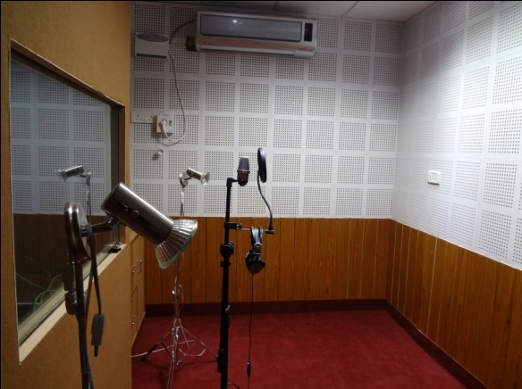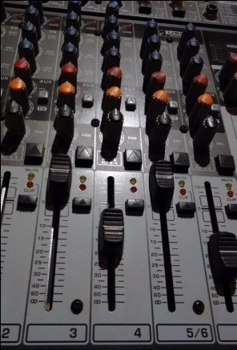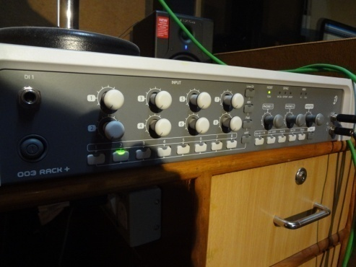

Documentation
In the academic year 2018-2019 we documented 1 major folk music event of Rajasthan in the form of Video for Archival purpose.
Library Updating
In the academic year 2018-2019 we could update our book library with 9 books, our e-book library with 3 e-books, video library with 55 hours of data and audio library with 335 hours of audio data.
Folk Instruments Collection
Nad Sadhna has its own museum of musical instruments. It even has the very rare Israj instrument of Baba Ustd. Allauddin Khan of Maihar. In the year 2018-2019 Nad Sadhna updated its museum with another 21 musical instruments from South Indian Music. The Museum has also been mapped with world museums by Sahapedia.
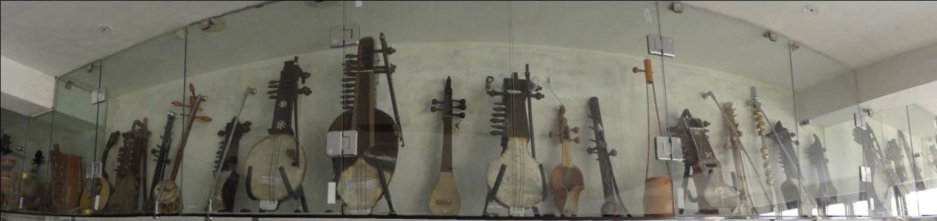

Exchange of Knowledge with International Scholars:
Nad Sadhna works as a channel for musicians and researchers from abroad and guides them as per their field. In this sequel, it the academic year 2018-2019 Besides 54 online queries there were 24 visitors and 16 researchers benefited by Nad Sadhna through exchange of knowledge.
Presentations and Concerts
- In the academic year 2018-2019 Nad Sadhna conducted 1 audio video presentation amongst students and learned audiences, and 4 lectures.
- 16th Thakur Kishan Singh sangeet samaroh was conducted in the month of April 2018 at Ravindra Manch in which Ustad Nisar Hussain on Tabla Jugalbandi with Shri Shafat Hussain and Dr. Ankit Bhatt presented Sitar Recital. Chief Guest was Mr. Yogendra Bhooshan.
- Indian classical concert by Khyal Maestero Pdt Kaivalya Kumar in association with NCPA, Mumbai was held on 1st March 2019 at JKK, Jaipur. After performance was a conversation session with famous art critic Mrs. Meena Banerjee.

Other Activities
- Representative from Nad Sadhna Attended the seminars held by ITC-SRA west zone in Mumbai
- Exhibition of folk musical instruments in Keshav Vidhya Pith in December 2017
- Updated the equipment at Nadsadhna
- Trial of Remaking of Hangdrum Musical Instrument was done on experimental basis

Plans for 2019-2020
Besides our routine activities, we propose a plan of our activities in the session 2018-19
- Attending the seminars held by ITC-SRA west zone.
- Planning a documentation of the musical instrument with the Institute.
- Completing the documentary film on the music practiced at Pushkar fair.
- Covering 2 major fairs in Rajasthan.
- Proposal for making documentary film the music at Pushkar Fair.
- Proposal and preparation for Exhibition of folk musical instruments .
- Updating the equipments at Nadsadhna .
- Planning 3 concerts in association with NCPA mumbai, 1 seminar, 3 talks and 5 presentations.
- Continuing Remaking of Hangdrum Musical Instrument.
- Updating museum with 12 new musical instruments.
- Getting associated with ICCR and ZCCs for joint projects.

